YEAR 10 SCIENCE
NATURAL AND PROCESSED MATERIALS
WORKSHEET - ELECTRON CONFIGURATION DRAWINGS

Draw electron configuration diagrams for the following elements. Show the number of protons and neutrons in the nucleus, and the number of electrons in each shell.

(a) 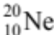 (b) 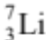

(c) 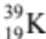 (d) 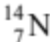

(e) 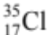 (f) 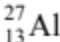

(g) 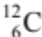 (h) 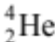

(i) 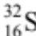 (j) 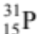

(k) 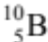 (l) 